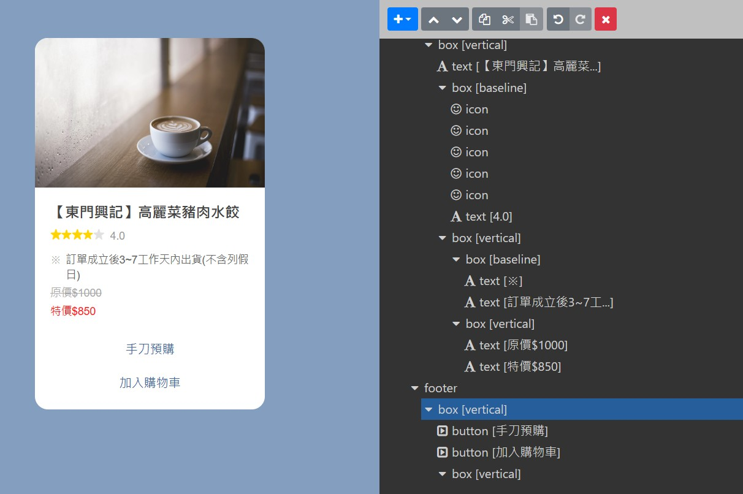
{
"type": "bubble",
"size": "mega",
"direction": "ltr",
"hero": {
"type": "image",
"size": "full",
"aspectRatio": "20:13",
"aspectMode": "cover",
"action": {
"type": "message",
"label": "action",
"text": "【林青霞的最愛回來台灣都必打包帶回香港】📢創立於民國39年 最早是以製麵起家，至今已有六十年多的歷史了 煮好的水餃可以感受到手工的口感，皮Q彈，果然跟機器的有差～ 每款餡料香甜肉扎實，一口咬下還有湯汁 好吃肉餡不油膩，裏頭的餡料比例調和的十分完美，根本就不用沾醬～一口接著一口🤤"
},
"url": "https://scdn.line-apps.com/n/channel_devcenter/img/fx/01_1_cafe.png"
},
"body": {
"type": "box",
"layout": "vertical",
"contents": [
{
"type": "text",
"text": "【東門興記】高麗菜豬肉水餃",
"weight": "bold",
"size": "lg"
},
{
"type": "box",
"layout": "baseline",
"margin": "md",
"contents": [
{
"type": "icon",
"size": "sm",
"url": "https://scdn.line-apps.com/n/channel_devcenter/img/fx/review_gold_star_28.png"
},
{
"type": "icon",
"size": "sm",
"url": "https://scdn.line-apps.com/n/channel_devcenter/img/fx/review_gold_star_28.png"
},
{
"type": "icon",
"size": "sm",
"url": "https://scdn.line-apps.com/n/channel_devcenter/img/fx/review_gold_star_28.png"
},
{
"type": "icon",
"size": "sm",
"url": "https://scdn.line-apps.com/n/channel_devcenter/img/fx/review_gold_star_28.png"
},
{
"type": "icon",
"size": "sm",
"url": "https://scdn.line-apps.com/n/channel_devcenter/img/fx/review_gray_star_28.png"
},
{
"type": "text",
"text": "4.0",
"size": "sm",
"color": "#999999",
"margin": "md",
"flex": 0
}
]
},
{
"type": "box",
"layout": "vertical",
"margin": "lg",
"spacing": "sm",
"contents": [
{
"type": "box",
"layout": "baseline",
"spacing": "sm",
"contents": [
{
"type": "text",
"text": "※",
"color": "#aaaaaa",
"size": "sm",
"flex": 1
},
{
"type": "text",
"text": "訂單成立後3~7工作天內出貨(不含列假日)",
"wrap": true,
"color": "#666666",
"size": "sm",
"flex": 15
}
]
},
{
"type": "box",
"layout": "vertical",
"spacing": "sm",
"contents": [
{
"type": "text",
"text": "原價$1000",
"color": "#aaaaaa",
"size": "sm",
"flex": 1,
"decoration": "line-through"
},
{
"type": "text",
"text": "特價$850",
"wrap": true,
"color": "#FF1212",
"size": "sm",
"flex": 5
}
]
}
]
}
]
},
"footer": {
"type": "box",
"layout": "vertical",
"spacing": "sm",
"contents": [
{
"type": "button",
"style": "link",
"height": "sm",
"action": {
"type": "message",
"label": "手刀預購",
"text": "【手刀預購】高麗菜水餃"
}
},
{
"type": "button",
"style": "link",
"height": "sm",
"action": {
"type": "message",
"label": "加入購物車",
"text": "加入購物車"
}
},
{
"type": "box",
"layout": "vertical",
"contents": [],
"margin": "sm"
}
],
"flex": 0,
"cornerRadius": "sm"
}
}

